Security: Przestrzeń kluczy XOR Vernam
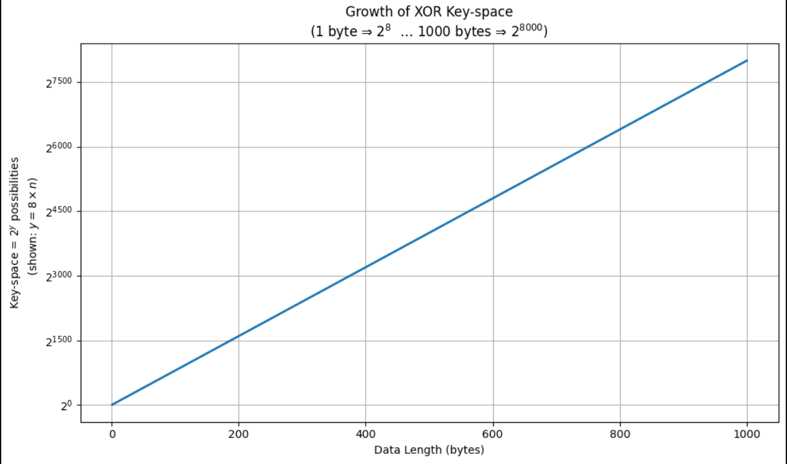
import matplotlib.pyplot as plt
import numpy as np
from matplotlib.ticker import FuncFormatter
# 1) Prepare the data
data_lengths = np.arange(1, 1001) # n = 1…1000 bytes
exponents = 8 * data_lengths # y = 8*n
# 2) Set up the formatter so ticks read as “2^{exponent}”
def exp_formatter(val, pos):
# only label integer ticks
iv = int(val)
if abs(val - iv) < 1e-6:
return f"$2^{{{iv}}}$"
else:
return ""
# 3) Plot
fig, ax = plt.subplots(figsize=(10,6))
ax.plot(data_lengths, exponents, linewidth=2)
ax.set_xlabel("Data Length (bytes)")
ax.set_ylabel("Key-space = $2^{y}$ possibilities\n (shown: $y = 8\\times n$)")
ax.set_title("Growth of XOR Key-space\n(1 byte ⇒ $2^8$ … 1000 bytes ⇒ $2^{8000}$)")
ax.grid(True)
# apply our custom formatter
ax.yaxis.set_major_locator(plt.MaxNLocator(8)) # about 8 ticks
ax.yaxis.set_major_formatter(FuncFormatter(exp_formatter))
plt.tight_layout()
plt.show()

