Security: pfSense IDS/IPS Snort
źródło: https://docs.netgate.com/pfsense/en/latest/packages/snort/setup.html

1. Konfiguracja kodu OinkCode
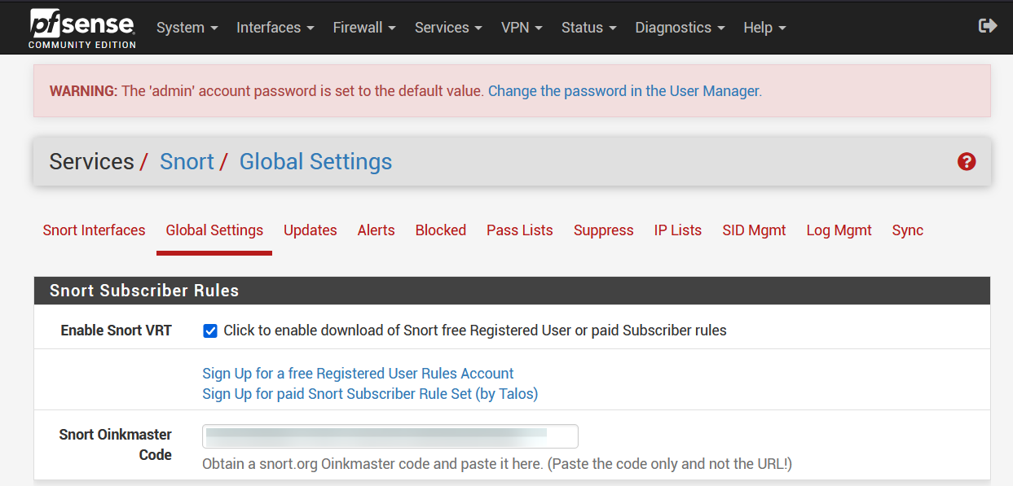

2. Wymuszenie aktualizacji zasad
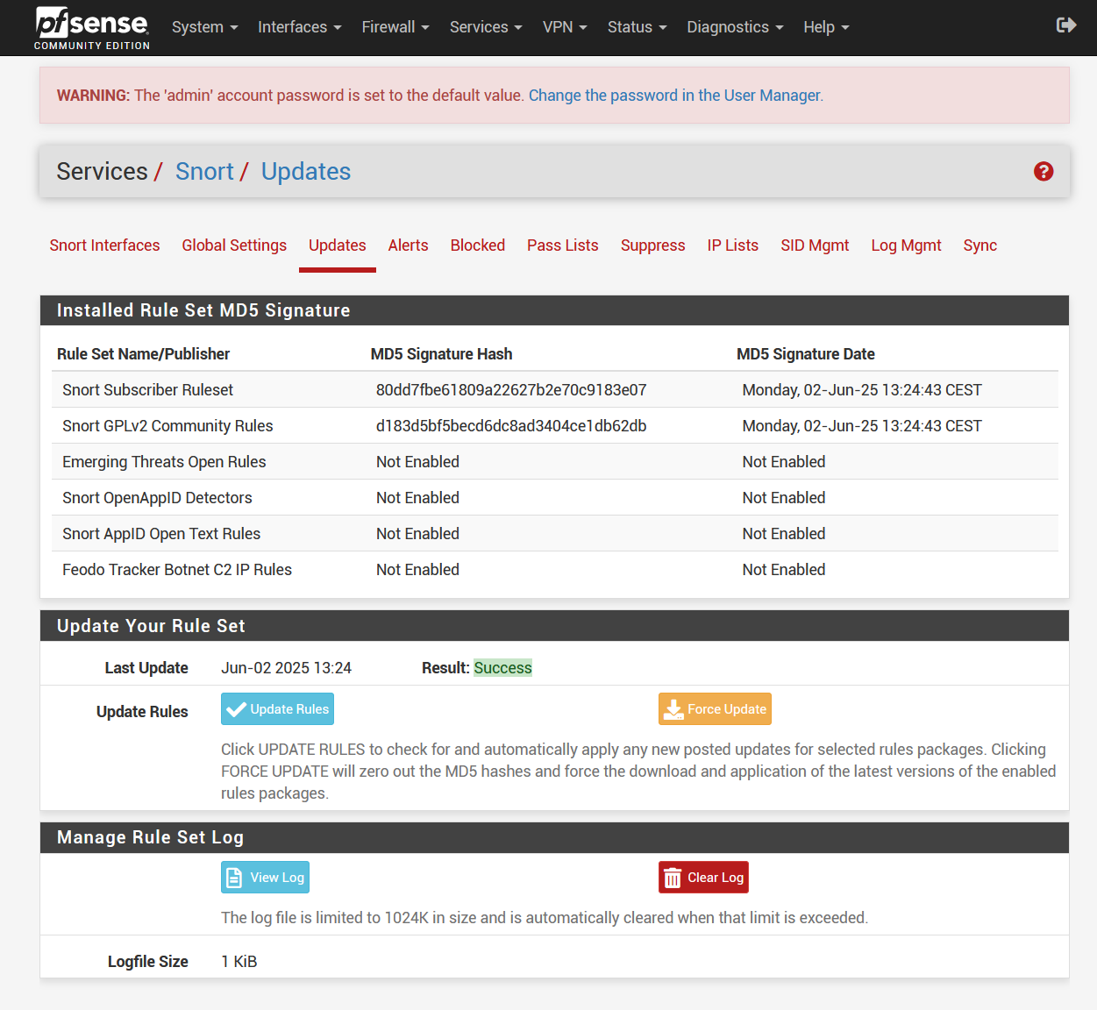

3. Dodanie interfejsu do monitorowania SNORT
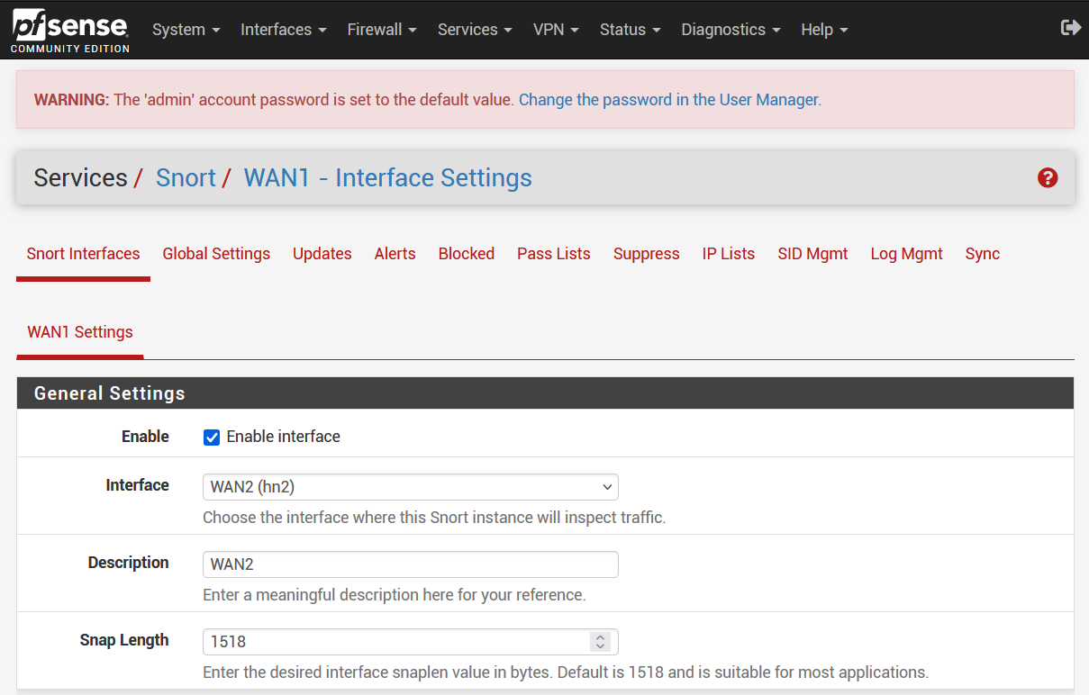

4. Włączenie zasad community GPLv2
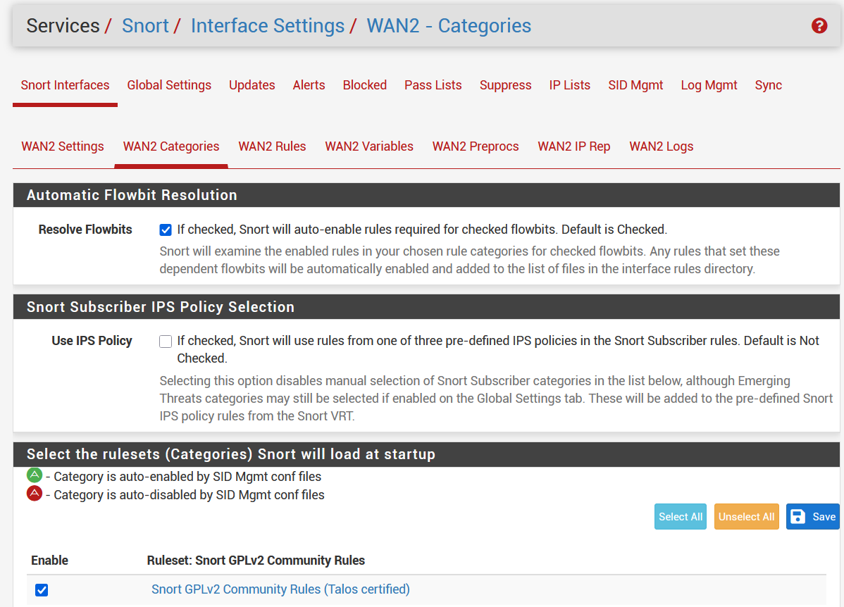

5. Dodanie zasady żeby ping był reportowany
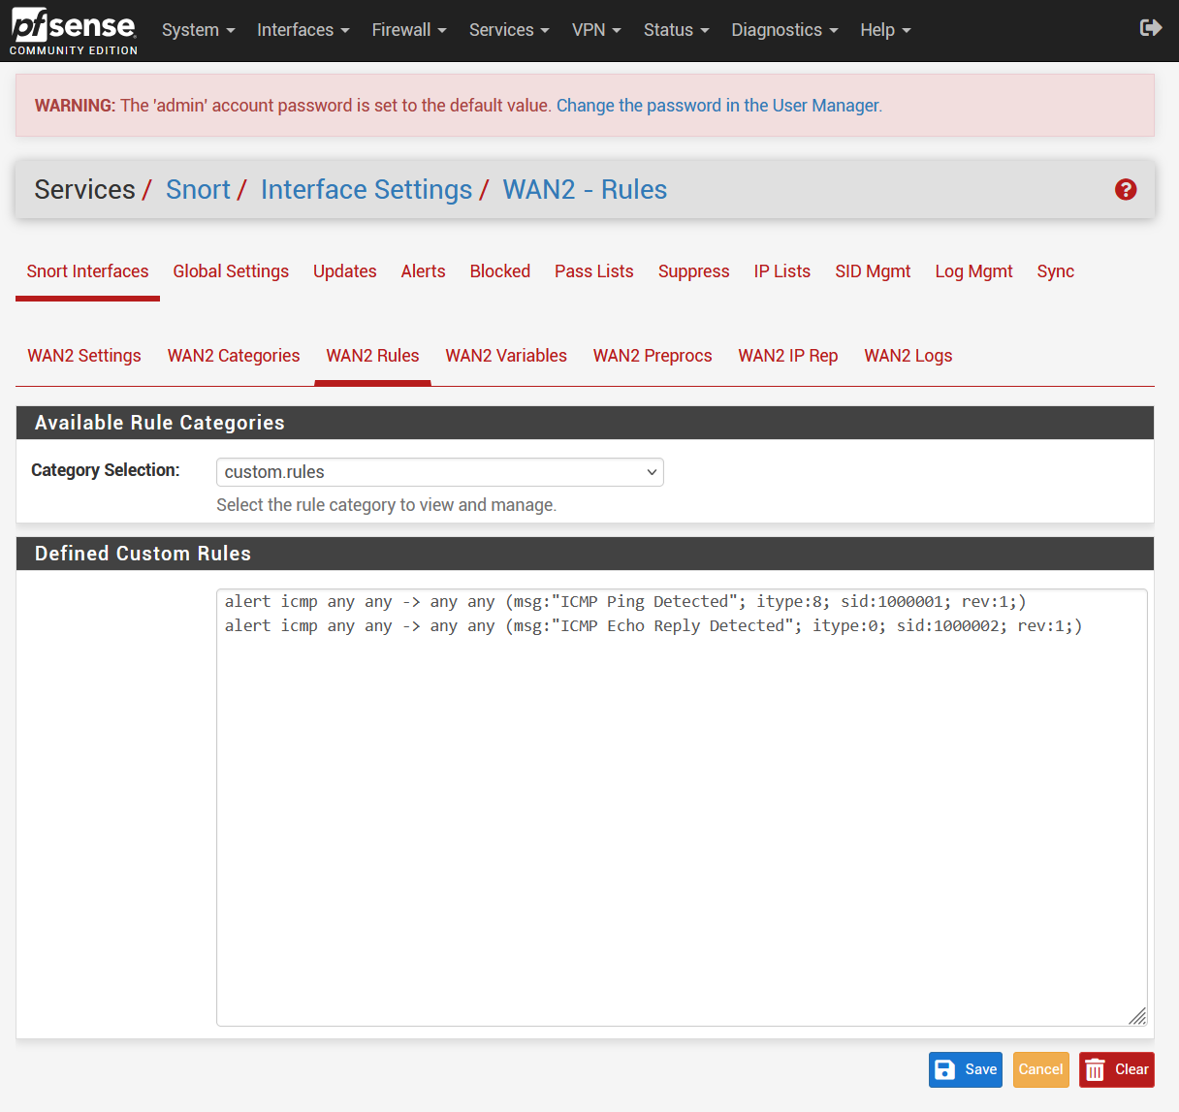

6. Test Ping
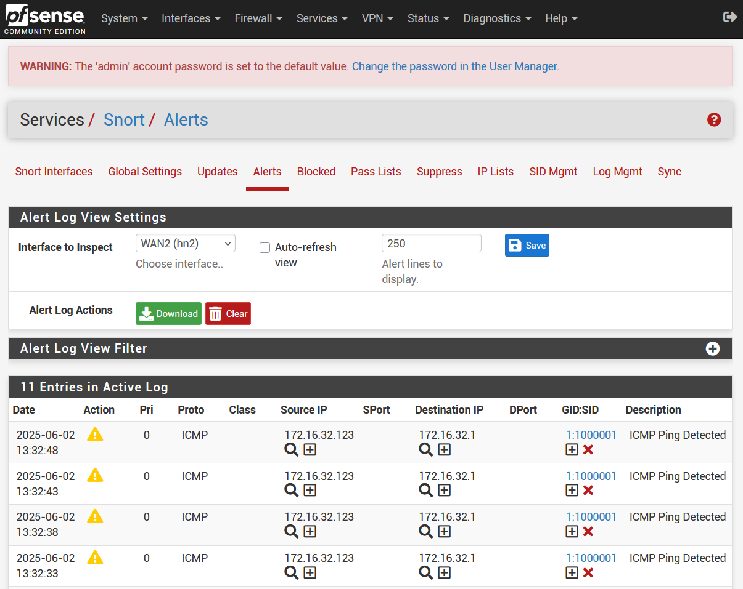

7. Dodanie innych reguł
reguły dodane w custom.rules:
# BLOCK ICMP PING (Echo Request)
drop icmp any any -> any any (msg:"BLOCKED: ICMP Ping Detected"; itype:8; sid:1000001; rev:1;)
# BLOCK NMAP Stealth Scan (SYN)
drop tcp any any -> any any (flags:S; msg:"BLOCKED: Nmap Stealth SYN Scan"; sid:1000002; rev:1;)
# BLOCK Null Scan
drop tcp any any -> any any (flags:0; msg:"BLOCKED: Null Scan Detected"; sid:1000003; rev:1;)
# BLOCK Xmas Scan
drop tcp any any -> any any (flags:FPU; msg:"BLOCKED: Xmas Scan Detected"; sid:1000004; rev:1;)
# BLOCK Shellcode-like Payloads
drop tcp any any -> any any (content:"|90 90 90|"; msg:"BLOCKED: NOP Sled (Shellcode) Detected"; sid:1000005; rev:1;)
# BLOCK FTP Login Attempt
drop tcp any any -> any 21 (msg:"BLOCKED: FTP Connection Attempt"; flags:S; sid:1000006; rev:1;)
# BLOCK Netcat Backdoor Attempt
drop tcp any any -> any 31337 (msg:"BLOCKED: Netcat Backdoor Connection Attempt"; sid:1000007; rev:1;)
# BLOCK HTTP Directory Traversal
drop tcp any any -> any 80 (msg:"BLOCKED: HTTP Directory Traversal"; content:"../"; http_uri; sid:1000008; rev:1;)
# BLOCK Suspicious User-Agent (e.g., sqlmap)
drop tcp any any -> any 80 (msg:"BLOCKED: Suspicious User-Agent - sqlmap"; content:"User-Agent|3A| sqlmap"; http_header; sid:1000009; rev:1;)
# BLOCK IRC Bot Connection Attempt
drop tcp any any -> any 6667 (msg:"BLOCKED: IRC Bot Connection Attempt"; sid:1000010; rev:1;)

8. Przetestowanie za pomocą kali linux
Historia poleceń kali:
104 ftp 172.16.32.1
105 ping 172.16.32.1
106 curl -A "Nikto" http://172.16.32.1/\n
107 nmap -sS -p 80 172.16.32.1\n
108 nmap -sN -p 80 172.16.32.1\n
109 nmap -sX -p 80 172.16.32.1\n
110 printf '\x90\x90\x90\x90\x90\x90' | nc 172.16.32.1 80\n
111 telnet 172.16.32.1 21\n
112 nc 172.16.32.1 31337\n
113 curl http://172.16.32.1/../../../etc/passwd\n
114 telnet 172.16.32.1 6667\n
115 (echo "NICK bot123"; echo "USER bot123 0 * :bot") | nc 172.16.32.1 6667\n
116 history | tail
Logi z snorta:
06/02/25-14:12:46.917675 ,1,1000002,1,"BLOCKED: Nmap Stealth SYN Scan",TCP,172.16.32.254,59316,172.16.32.1,80,28762,,0,alert,Allow
06/02/25-14:12:56.162596 ,1,1000003,1,"BLOCKED: Null Scan Detected",TCP,172.16.32.254,57001,172.16.32.1,80,20142,,0,alert,Allow
06/02/25-14:12:56.262709 ,1,1000003,1,"BLOCKED: Null Scan Detected",TCP,172.16.32.254,57003,172.16.32.1,80,53859,,0,alert,Allow
06/02/25-14:13:02.802919 ,1,1000004,1,"BLOCKED: Xmas Scan Detected",TCP,172.16.32.254,55633,172.16.32.1,80,941,,0,alert,Allow
06/02/25-14:13:02.902978 ,1,1000004,1,"BLOCKED: Xmas Scan Detected",TCP,172.16.32.254,55635,172.16.32.1,80,14216,,0,alert,Allow
06/02/25-14:13:13.470221 ,1,1000002,1,"BLOCKED: Nmap Stealth SYN Scan",TCP,172.16.32.254,50274,172.16.32.1,80,33290,,0,alert,Allow
06/02/25-14:13:13.470506 ,1,1000005,1,"BLOCKED: NOP Sled (Shellcode) Detected",TCP,172.16.32.254,50274,172.16.32.1,80,33292,,0,alert,Allow
06/02/25-14:13:24.157371 ,1,1000006,1,"BLOCKED: FTP Connection Attempt",TCP,172.16.32.254,36064,172.16.32.1,21,21358,,0,alert,Allow
06/02/25-14:13:24.157371 ,1,1000002,1,"BLOCKED: Nmap Stealth SYN Scan",TCP,172.16.32.254,36064,172.16.32.1,21,21358,,0,alert,Allow
06/02/25-14:13:25.159722 ,1,1000006,1,"BLOCKED: FTP Connection Attempt",TCP,172.16.32.254,36064,172.16.32.1,21,21359,,0,alert,Allow
06/02/25-14:13:25.159722 ,1,1000002,1,"BLOCKED: Nmap Stealth SYN Scan",TCP,172.16.32.254,36064,172.16.32.1,21,21359,,0,alert,Allow
06/02/25-14:13:26.183775 ,1,1000006,1,"BLOCKED: FTP Connection Attempt",TCP,172.16.32.254,36064,172.16.32.1,21,21360,,0,alert,Allow
06/02/25-14:13:26.183775 ,1,1000002,1,"BLOCKED: Nmap Stealth SYN Scan",TCP,172.16.32.254,36064,172.16.32.1,21,21360,,0,alert,Allow
06/02/25-14:13:27.207614 ,1,1000006,1,"BLOCKED: FTP Connection Attempt",TCP,172.16.32.254,36064,172.16.32.1,21,21361,,0,alert,Allow
06/02/25-14:13:27.207614 ,1,1000002,1,"BLOCKED: Nmap Stealth SYN Scan",TCP,172.16.32.254,36064,172.16.32.1,21,21361,,0,alert,Allow
06/02/25-14:13:28.231515 ,1,1000006,1,"BLOCKED: FTP Connection Attempt",TCP,172.16.32.254,36064,172.16.32.1,21,21362,,0,alert,Allow
06/02/25-14:13:28.231515 ,1,1000002,1,"BLOCKED: Nmap Stealth SYN Scan",TCP,172.16.32.254,36064,172.16.32.1,21,21362,,0,alert,Allow
06/02/25-14:13:29.255534 ,1,1000006,1,"BLOCKED: FTP Connection Attempt",TCP,172.16.32.254,36064,172.16.32.1,21,21363,,0,alert,Allow
06/02/25-14:13:29.255534 ,1,1000002,1,"BLOCKED: Nmap Stealth SYN Scan",TCP,172.16.32.254,36064,172.16.32.1,21,21363,,0,alert,Allow
06/02/25-14:13:31.271781 ,1,1000006,1,"BLOCKED: FTP Connection Attempt",TCP,172.16.32.254,36064,172.16.32.1,21,21364,,0,alert,Allow
06/02/25-14:13:31.271781 ,1,1000002,1,"BLOCKED: Nmap Stealth SYN Scan",TCP,172.16.32.254,36064,172.16.32.1,21,21364,,0,alert,Allow
06/02/25-14:13:39.211300 ,1,1000007,1,"BLOCKED: Netcat Backdoor Connection Attempt",TCP,172.16.32.254,60662,172.16.32.1,31337,10892,,0,alert,Allow
06/02/25-14:13:39.211300 ,1,1000002,1,"BLOCKED: Nmap Stealth SYN Scan",TCP,172.16.32.254,60662,172.16.32.1,31337,10892,,0,alert,Allow
06/02/25-14:13:40.232112 ,1,1000007,1,"BLOCKED: Netcat Backdoor Connection Attempt",TCP,172.16.32.254,60662,172.16.32.1,31337,10893,,0,alert,Allow
06/02/25-14:13:40.232112 ,1,1000002,1,"BLOCKED: Nmap Stealth SYN Scan",TCP,172.16.32.254,60662,172.16.32.1,31337,10893,,0,alert,Allow
06/02/25-14:13:41.256123 ,1,1000007,1,"BLOCKED: Netcat Backdoor Connection Attempt",TCP,172.16.32.254,60662,172.16.32.1,31337,10894,,0,alert,Allow
06/02/25-14:13:41.256123 ,1,1000002,1,"BLOCKED: Nmap Stealth SYN Scan",TCP,172.16.32.254,60662,172.16.32.1,31337,10894,,0,alert,Allow
06/02/25-14:13:42.280290 ,1,1000007,1,"BLOCKED: Netcat Backdoor Connection Attempt",TCP,172.16.32.254,60662,172.16.32.1,31337,10895,,0,alert,Allow
06/02/25-14:13:42.280290 ,1,1000002,1,"BLOCKED: Nmap Stealth SYN Scan",TCP,172.16.32.254,60662,172.16.32.1,31337,10895,,0,alert,Allow
06/02/25-14:13:43.304868 ,1,1000007,1,"BLOCKED: Netcat Backdoor Connection Attempt",TCP,172.16.32.254,60662,172.16.32.1,31337,10896,,0,alert,Allow
06/02/25-14:13:43.304868 ,1,1000002,1,"BLOCKED: Nmap Stealth SYN Scan",TCP,172.16.32.254,60662,172.16.32.1,31337,10896,,0,alert,Allow
06/02/25-14:13:44.328926 ,1,1000007,1,"BLOCKED: Netcat Backdoor Connection Attempt",TCP,172.16.32.254,60662,172.16.32.1,31337,10897,,0,alert,Allow
06/02/25-14:13:44.328926 ,1,1000002,1,"BLOCKED: Nmap Stealth SYN Scan",TCP,172.16.32.254,60662,172.16.32.1,31337,10897,,0,alert,Allow
06/02/25-14:13:46.345070 ,1,1000007,1,"BLOCKED: Netcat Backdoor Connection Attempt",TCP,172.16.32.254,60662,172.16.32.1,31337,10898,,0,alert,Allow
06/02/25-14:13:46.345070 ,1,1000002,1,"BLOCKED: Nmap Stealth SYN Scan",TCP,172.16.32.254,60662,172.16.32.1,31337,10898,,0,alert,Allow
06/02/25-14:13:50.504788 ,1,1000007,1,"BLOCKED: Netcat Backdoor Connection Attempt",TCP,172.16.32.254,60662,172.16.32.1,31337,10899,,0,alert,Allow
06/02/25-14:13:50.504788 ,1,1000002,1,"BLOCKED: Nmap Stealth SYN Scan",TCP,172.16.32.254,60662,172.16.32.1,31337,10899,,0,alert,Allow
06/02/25-14:14:09.844453 ,1,1000002,1,"BLOCKED: Nmap Stealth SYN Scan",TCP,172.16.32.254,49382,172.16.32.1,80,54462,,0,alert,Allow
06/02/25-14:14:22.932873 ,1,1000002,1,"BLOCKED: Nmap Stealth SYN Scan",TCP,172.16.32.254,56748,172.16.32.1,80,50731,,0,alert,Allow
06/02/25-14:14:40.027235 ,1,1000010,1,"BLOCKED: IRC Bot Connection Attempt",TCP,172.16.32.254,43038,172.16.32.1,6667,25393,,0,alert,Allow
06/02/25-14:14:40.027235 ,1,1000002,1,"BLOCKED: Nmap Stealth SYN Scan",TCP,172.16.32.254,43038,172.16.32.1,6667,25393,,0,alert,Allow
06/02/25-14:14:41.035377 ,1,1000010,1,"BLOCKED: IRC Bot Connection Attempt",TCP,172.16.32.254,43038,172.16.32.1,6667,25394,,0,alert,Allow
06/02/25-14:14:41.035377 ,1,1000002,1,"BLOCKED: Nmap Stealth SYN Scan",TCP,172.16.32.254,43038,172.16.32.1,6667,25394,,0,alert,Allow
06/02/25-14:14:42.059513 ,1,1000010,1,"BLOCKED: IRC Bot Connection Attempt",TCP,172.16.32.254,43038,172.16.32.1,6667,25395,,0,alert,Allow
06/02/25-14:14:42.059513 ,1,1000002,1,"BLOCKED: Nmap Stealth SYN Scan",TCP,172.16.32.254,43038,172.16.32.1,6667,25395,,0,alert,Allow
06/02/25-14:14:43.083451 ,1,1000010,1,"BLOCKED: IRC Bot Connection Attempt",TCP,172.16.32.254,43038,172.16.32.1,6667,25396,,0,alert,Allow
06/02/25-14:14:43.083451 ,1,1000002,1,"BLOCKED: Nmap Stealth SYN Scan",TCP,172.16.32.254,43038,172.16.32.1,6667,25396,,0,alert,Allow
06/02/25-14:14:44.107513 ,1,1000010,1,"BLOCKED: IRC Bot Connection Attempt",TCP,172.16.32.254,43038,172.16.32.1,6667,25397,,0,alert,Allow
06/02/25-14:14:44.107513 ,1,1000002,1,"BLOCKED: Nmap Stealth SYN Scan",TCP,172.16.32.254,43038,172.16.32.1,6667,25397,,0,alert,Allow
06/02/25-14:14:45.131737 ,1,1000010,1,"BLOCKED: IRC Bot Connection Attempt",TCP,172.16.32.254,43038,172.16.32.1,6667,25398,,0,alert,Allow
06/02/25-14:14:45.131737 ,1,1000002,1,"BLOCKED: Nmap Stealth SYN Scan",TCP,172.16.32.254,43038,172.16.32.1,6667,25398,,0,alert,Allow
06/02/25-14:14:47.147642 ,1,1000010,1,"BLOCKED: IRC Bot Connection Attempt",TCP,172.16.32.254,43038,172.16.32.1,6667,25399,,0,alert,Allow
06/02/25-14:14:47.147642 ,1,1000002,1,"BLOCKED: Nmap Stealth SYN Scan",TCP,172.16.32.254,43038,172.16.32.1,6667,25399,,0,alert,Allow
06/02/25-14:14:53.869755 ,1,1000010,1,"BLOCKED: IRC Bot Connection Attempt",TCP,172.16.32.254,37488,172.16.32.1,6667,3048,,0,alert,Allow
06/02/25-14:14:53.869755 ,1,1000002,1,"BLOCKED: Nmap Stealth SYN Scan",TCP,172.16.32.254,37488,172.16.32.1,6667,3048,,0,alert,Allow
06/02/25-14:14:54.892010 ,1,1000010,1,"BLOCKED: IRC Bot Connection Attempt",TCP,172.16.32.254,37488,172.16.32.1,6667,3049,,0,alert,Allow
06/02/25-14:14:54.892010 ,1,1000002,1,"BLOCKED: Nmap Stealth SYN Scan",TCP,172.16.32.254,37488,172.16.32.1,6667,3049,,0,alert,Allow
06/02/25-14:14:55.916047 ,1,1000010,1,"BLOCKED: IRC Bot Connection Attempt",TCP,172.16.32.254,37488,172.16.32.1,6667,3050,,0,alert,Allow
06/02/25-14:14:55.916047 ,1,1000002,1,"BLOCKED: Nmap Stealth SYN Scan",TCP,172.16.32.254,37488,172.16.32.1,6667,3050,,0,alert,Allow
06/02/25-14:14:56.940076 ,1,1000010,1,"BLOCKED: IRC Bot Connection Attempt",TCP,172.16.32.254,37488,172.16.32.1,6667,3051,,0,alert,Allow
06/02/25-14:14:56.940076 ,1,1000002,1,"BLOCKED: Nmap Stealth SYN Scan",TCP,172.16.32.254,37488,172.16.32.1,6667,3051,,0,alert,Allow
06/02/25-14:14:57.964416 ,1,1000010,1,"BLOCKED: IRC Bot Connection Attempt",TCP,172.16.32.254,37488,172.16.32.1,6667,3052,,0,alert,Allow
06/02/25-14:14:57.964416 ,1,1000002,1,"BLOCKED: Nmap Stealth SYN Scan",TCP,172.16.32.254,37488,172.16.32.1,6667,3052,,0,alert,Allow
06/02/25-14:14:58.988306 ,1,1000010,1,"BLOCKED: IRC Bot Connection Attempt",TCP,172.16.32.254,37488,172.16.32.1,6667,3053,,0,alert,Allow
06/02/25-14:14:58.988306 ,1,1000002,1,"BLOCKED: Nmap Stealth SYN Scan",TCP,172.16.32.254,37488,172.16.32.1,6667,3053,,0,alert,Allow
06/02/25-14:15:01.004515 ,1,1000010,1,"BLOCKED: IRC Bot Connection Attempt",TCP,172.16.32.254,37488,172.16.32.1,6667,3054,,0,alert,Allow
06/02/25-14:15:01.004515 ,1,1000002,1,"BLOCKED: Nmap Stealth SYN Scan",TCP,172.16.32.254,37488,172.16.32.1,6667,3054,,0,alert,Allow

