Cisco: GRE tunel

Notatki:
test:
PC2#ping 10.0.0.254
Type escape sequence to abort.
Sending 5, 100-byte ICMP Echos to 10.0.0.254, timeout is 2 seconds:
!!!!!
Success rate is 100 percent (5/5), round-trip min/avg/max = 44/56/76 ms
PC2#traceroute 10.0.0.254
Type escape sequence to abort.
Tracing the route to 10.0.0.254
1 172.16.1.1 32 msec 32 msec 32 msec
2 192.168.3.1 28 msec 20 msec 44 msec
3 10.0.0.254 44 msec 60 msec 64 msec
PC2#
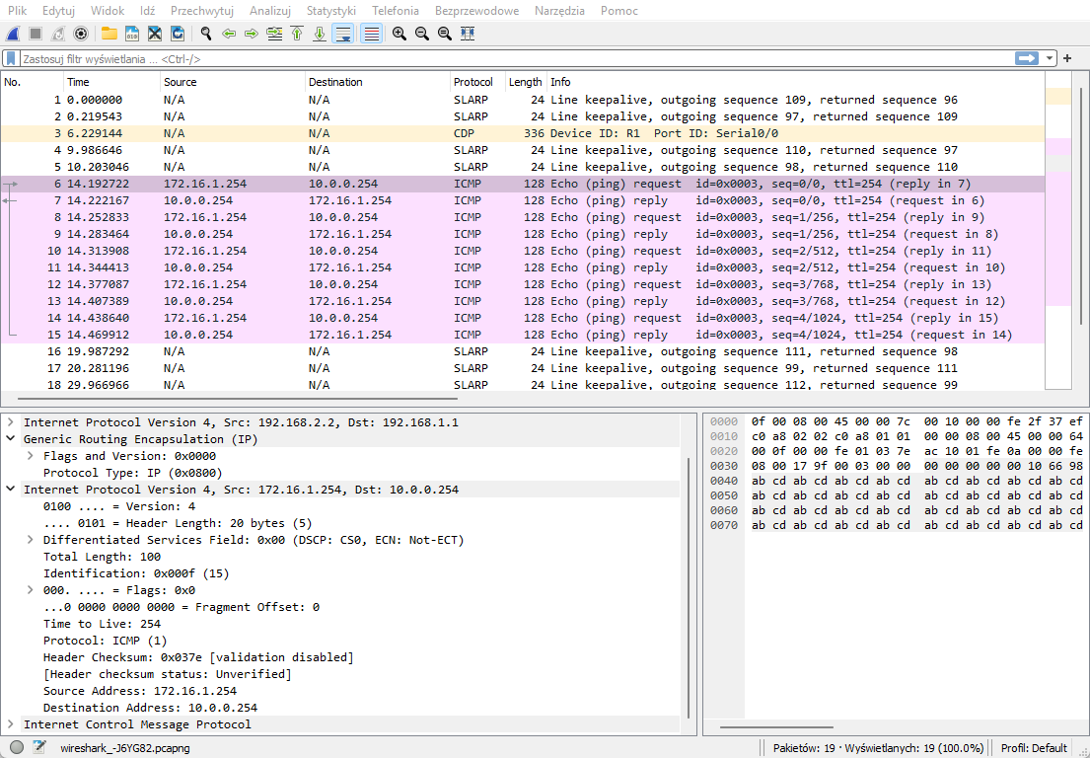
R1:
interface Tunnel0
ip address 192.168.3.1 255.255.255.0
tunnel source 192.168.1.1
tunnel destination 192.168.2.2
R3:
interface Tunnel0
ip address 192.168.3.2 255.255.255.0
tunnel source 192.168.2.2
tunnel destination 192.168.1.1

GNS3
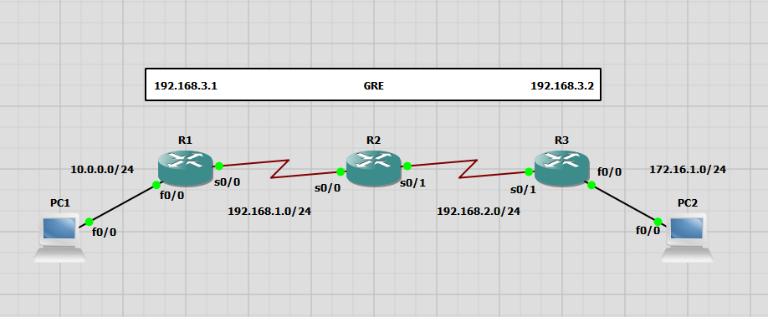
Konfiguracja R1:
Building configuration...
Current configuration : 1482 bytes
!
version 12.4
service timestamps debug datetime msec
service timestamps log datetime msec
no service password-encryption
!
hostname R1
!
boot-start-marker
boot-end-marker
!
!
no aaa new-model
memory-size iomem 5
no ip icmp rate-limit unreachable
ip cef
!
!
!
!
no ip domain lookup
!
multilink bundle-name authenticated
!
!
!
!
!
!
!
!
!
!
!
!
!
!
!
!
!
!
!
!
!
archive
log config
hidekeys
!
!
!
!
ip tcp synwait-time 5
!
!
!
!
interface Tunnel0
ip address 192.168.3.1 255.255.255.0
tunnel source 192.168.1.1
tunnel destination 192.168.2.2
!
interface FastEthernet0/0
ip address 10.0.0.1 255.255.255.0
duplex auto
speed auto
!
interface Serial0/0
ip address 192.168.1.1 255.255.255.0
clock rate 2000000
!
interface FastEthernet0/1
no ip address
shutdown
duplex auto
speed auto
!
interface Serial0/1
no ip address
shutdown
clock rate 2000000
!
interface Serial0/2
no ip address
shutdown
clock rate 2000000
!
interface FastEthernet1/0
no ip address
shutdown
duplex auto
speed auto
!
interface FastEthernet2/0
no ip address
shutdown
duplex auto
speed auto
!
ip forward-protocol nd
ip route 0.0.0.0 0.0.0.0 192.168.1.2
ip route 172.16.1.0 255.255.255.0 192.168.3.2
!
!
no ip http server
no ip http secure-server
!
no cdp log mismatch duplex
!
!
!
!
!
!
control-plane
!
!
!
!
!
!
!
!
!
!
line con 0
exec-timeout 0 0
privilege level 15
logging synchronous
line aux 0
exec-timeout 0 0
privilege level 15
logging synchronous
line vty 0 4
login
!
!
end
Konfiguracja R2:
Destination filename [startup-config]?
Building configuration...
[OK]
R2#
*Mar 1 00:09:02.183: %LINEPROTO-5-UPDOWN: Line protocol on Interface Serial0/1, changed state to up
R2#show run
Building configuration...
Current configuration : 1285 bytes
!
version 12.4
service timestamps debug datetime msec
service timestamps log datetime msec
no service password-encryption
!
hostname R2
!
boot-start-marker
boot-end-marker
!
!
no aaa new-model
memory-size iomem 5
no ip icmp rate-limit unreachable
ip cef
!
!
!
!
no ip domain lookup
!
multilink bundle-name authenticated
!
!
!
!
!
!
!
!
!
!
!
!
!
!
!
!
!
!
!
!
!
archive
log config
hidekeys
!
!
!
!
ip tcp synwait-time 5
!
!
!
!
interface FastEthernet0/0
no ip address
shutdown
duplex auto
speed auto
!
interface Serial0/0
ip address 192.168.1.2 255.255.255.0
clock rate 2000000
!
interface FastEthernet0/1
no ip address
shutdown
duplex auto
speed auto
!
interface Serial0/1
ip address 192.168.2.1 255.255.255.0
clock rate 2000000
!
interface Serial0/2
no ip address
shutdown
clock rate 2000000
!
interface FastEthernet1/0
no ip address
shutdown
duplex auto
speed auto
!
interface FastEthernet2/0
no ip address
shutdown
duplex auto
speed auto
!
ip forward-protocol nd
!
!
no ip http server
no ip http secure-server
!
no cdp log mismatch duplex
!
!
!
!
!
!
control-plane
!
!
!
!
!
!
!
!
!
!
line con 0
exec-timeout 0 0
privilege level 15
logging synchronous
line aux 0
exec-timeout 0 0
privilege level 15
logging synchronous
line vty 0 4
login
!
!
end
Konfiguracja R3:
Building configuration...
Current configuration : 1482 bytes
!
version 12.4
service timestamps debug datetime msec
service timestamps log datetime msec
no service password-encryption
!
hostname R3
!
boot-start-marker
boot-end-marker
!
!
no aaa new-model
memory-size iomem 5
no ip icmp rate-limit unreachable
ip cef
!
!
!
!
no ip domain lookup
!
multilink bundle-name authenticated
!
!
!
!
!
!
!
!
!
!
!
!
!
!
!
!
!
!
!
!
!
archive
log config
hidekeys
!
!
!
!
ip tcp synwait-time 5
!
!
!
!
interface Tunnel0
ip address 192.168.3.2 255.255.255.0
tunnel source 192.168.2.2
tunnel destination 192.168.1.1
!
interface FastEthernet0/0
ip address 172.16.1.1 255.255.255.0
duplex auto
speed auto
!
interface Serial0/0
no ip address
shutdown
clock rate 2000000
!
interface FastEthernet0/1
no ip address
shutdown
duplex auto
speed auto
!
interface Serial0/1
ip address 192.168.2.2 255.255.255.0
clock rate 2000000
!
interface Serial0/2
no ip address
shutdown
clock rate 2000000
!
interface FastEthernet1/0
no ip address
shutdown
duplex auto
speed auto
!
interface FastEthernet2/0
no ip address
shutdown
duplex auto
speed auto
!
ip forward-protocol nd
ip route 0.0.0.0 0.0.0.0 192.168.2.1
ip route 10.0.0.0 255.255.255.0 192.168.3.1
!
!
no ip http server
no ip http secure-server
!
no cdp log mismatch duplex
!
!
!
!
!
!
control-plane
!
!
!
!
!
!
!
!
!
!
line con 0
exec-timeout 0 0
privilege level 15
logging synchronous
line aux 0
exec-timeout 0 0
privilege level 15
logging synchronous
line vty 0 4
login
!
!
end

