C++: Porównanie wydajności sortowań
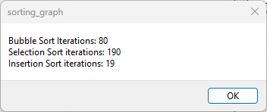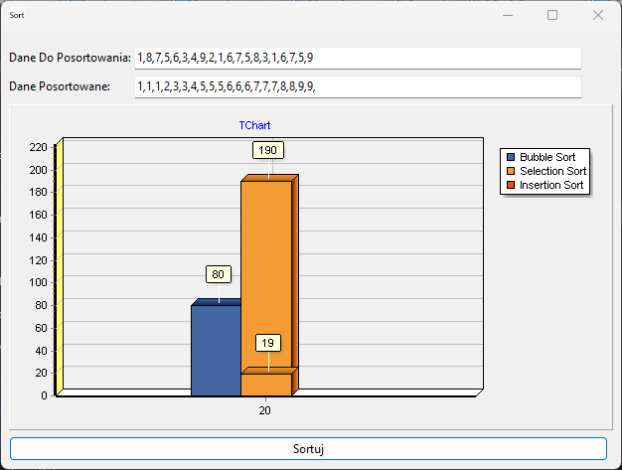
pliki:
- sorting_graphs.zip
kod:
//---------------------------------------------------------------------------
#include <vcl.h>
#pragma hdrstop
#include "Unit2.h"
#include <string>
//---------------------------------------------------------------------------
#pragma package(smart_init)
#pragma resource "*.dfm"
TForm2 *Form2;
//---------------------------------------------------------------------------
__fastcall TForm2::TForm2(TComponent* Owner)
: TForm(Owner)
{
//AllocConsole();
//freopen("CONIN$", "r", stdin);
//freopen("CONOUT$", "w", stdout);
//freopen("CONOUT$", "w", stderr);
}
//---------------------------------------------------------------------------
int iterationsBubble;
int* bubbleSort(int arr[], int size) {
iterationsBubble = 0;
for (int i = 0; i < size; ++i) {
for (int j = 0; j < size - i; ++j) {
if (arr[j] > arr[j + 1]) {
// Swap elements if they are in the wrong order
int temp = arr[j];
arr[j] = arr[j + 1];
arr[j + 1] = temp;
iterationsBubble++;
}
}
}
//ShowMessage("Bubble Sort Iterations: " + IntToStr(iterationsBubble));
return arr; // Return the sorted array
}
int iterationsSelection;
int* selectionSort(int arr[], int size) {
iterationsSelection = 0;
for (int i = 0; i < size - 1; ++i) {
int minIndex = i;
// Find the index of the minimum element in the unsorted part of the array
for (int j = i + 1; j < size; ++j) {
if (arr[j] < arr[minIndex]) {
minIndex = j;
}
iterationsSelection ++;
}
// Swap the found minimum element with the first element
int temp = arr[i];
arr[i] = arr[minIndex];
arr[minIndex] = temp;
}
return arr; // Return the sorted array
}
int iterationsInsertion;
int* insertionSort(int arr[], int size) {
iterationsInsertion = 0;
for (int i = 1; i < size; ++i) {
int key = arr[i];
int j = i - 1;
// Move elements greater than key to
//one position ahead of their current position
while (j >= 0 && arr[j] > key) {
arr[j + 1] = arr[j];
j = j - 1;
}
arr[j + 1] = key;
iterationsInsertion++;
}
return arr; // Return the sorted array
}
/*
String intArrayToString(int arr[], int size) {
String result = "";
for (int i = 0; i < size; ++i) {
if (i > 0) {
result += ",";
}
result += IntToStr(arr[i]);
}
return result;
}
*/
void __fastcall TForm2::SortButtonClick(TObject *Sender)
{
String strData = DataTextBox->Text;
std::cout << AnsiString(strData).c_str() << std::endl;
int counter = 0;
for (int i = 1; i <= strData.Length(); i++) {
if (strData[i] == ',') {
counter++;
}
}
std::cout << AnsiString(counter+1).c_str() << std::endl;
// Dynamically allocate memory for intDataArray
int* intDataArray = new int[counter + 1];
// Initialize the array elements to avoid garbage values
for (int i = 0; i <= counter; ++i) {
intDataArray[i] = 0; // You can use any default value here
}
int numElement = 0;
String element = "";
int x = 0;
for (int i = 1; i <= strData.Length(); i++) {
x = i;
if (strData[i] == ',') {
numElement++;
intDataArray[numElement] = StrToInt(element);
std::cout << AnsiString("element:"+element).c_str() << std::endl;
element = ""; // Reset element for the next iteration
}
else if (i == strData.Length()) {
element += strData[i];
numElement++;
intDataArray[numElement] = StrToInt(element);
std::cout << AnsiString("element:"+element).c_str() << std::endl;
element = ""; // Reset element for the next iteration
} else {
element += strData[i];
}
}
int arraySize = counter + 1;
int* sortedArray = bubbleSort(intDataArray, arraySize);
SortedDataTextBox->Text = "";
for (int i = 1; i <= arraySize; i++) {
SortedDataTextBox->Text += IntToStr(sortedArray[i]);
SortedDataTextBox->Text += ",";
}
selectionSort(intDataArray, arraySize);
insertionSort(intDataArray, arraySize);
ShowMessage("Bubble Sort Iterations: " + IntToStr(iterationsBubble)
+ "\nSelection Sort iterations: "+IntToStr(iterationsSelection)+
"\nInsertion Sort iterations: "+IntToStr(iterationsInsertion));
Series1->AddXY(arraySize,iterationsBubble);
Series2->AddXY(arraySize,iterationsSelection);
Series2->AddXY(arraySize,iterationsInsertion);
//String arrayString = intArrayToString(sortedString, arraySize);
//SortedDataTextBox->Text = arrayString;
// Don't forget to release the dynamically allocated memory
delete[] intDataArray;
}
//---------------------------------------------------------------------------

