Translation plugin
In the top right corner of every article there is a button which allows you to select translated page of the wiki
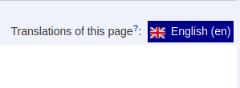
If it is greyed out it means there is no translation yet.
When you switch on the start page to English you will see only translated articles in every sub namespace. Because everything that is translated to English is under en: namespace. So basically there are two instances of the Wiki one is the regular main instance that is in the root namespace and second one is the second instance that is under en: namespace. Not everything is in every instance some articles are only in English Wiki some are only in Polish.
I am trying my best to translate this wiki in to English but it is not that easy, and it takes a lot of work, so please be patient. Translations are also mostly hand made by me, so they are not 100% accurate to the original text sometimes but i am trying my best. One day I will translate everything, hopefully …
If you want to see the progress of my translation i highly encourage you to go to the Mindmap php script that i made that shows file structure of the Wiki in a tree graph, there you can see how many articles are under en: namespace. At the time of writing this, there are not that many articles there yet …
New articles that i add, are being made in two languages simultaneously, or sometimes in English only.


