Other Materials
In this section, you will find materials that I found difficult to classify into other categories:
Presentation: Hacking in Practice (Only in Polish)
A presentation from the March 2020 conference at the communications school complex, discussing low-level exploitation and the security of unencrypted network transmission.
referat_5g.pdf
A short note explaining how 5G networks work and why they do not cause cancer. (Only in Polish)
Website with weather forecast for Warsaw
A simple website with an iframe displaying the weather from wttr.in.
pin_tunel.pdf
A paper comparing different types of semiconductor diodes. (Only in Polish)
Virtual Board
Screenshots of the virtual board from the training courses and classes I teach (Only In Polish)
XYZ Catalog
It's a digital “treasure trove” – I put everything here that might be useful for tutoring, from notes to strange files that I once needed for something. (Mostly Polish Stuffs)

Mathematical visualizations in GeoGebra
Illustration | Geogebra file | Info
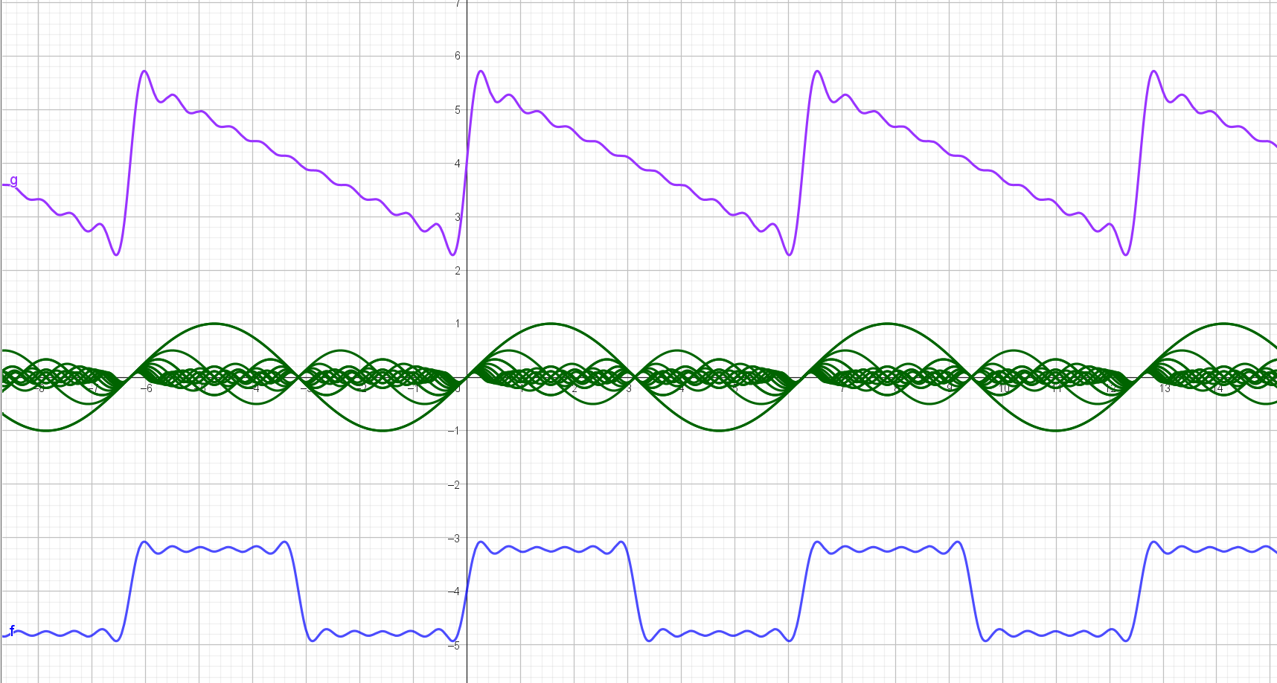 | fft.ggb | https://en.wikipedia.org/wiki/Fast_Fourier_transform
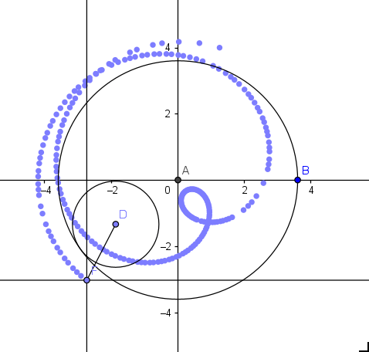 | hypotrochoid.ggb | https://en.wikipedia.org/wiki/Hypotrochoid
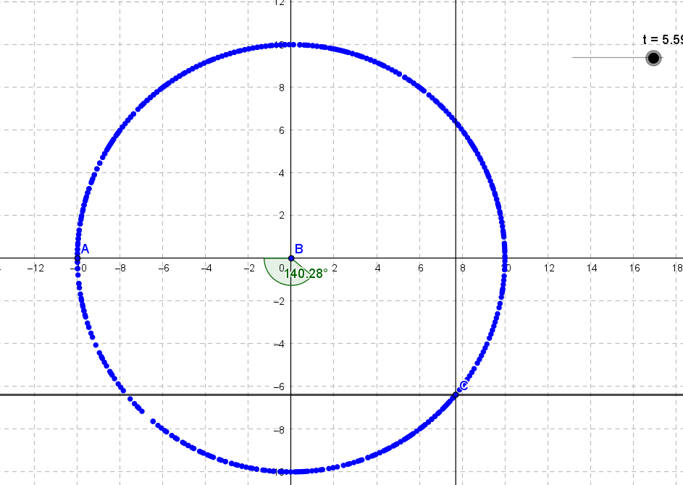 | kolo.ggb | https://pl.wikipedia.org/wiki/Okr%C4%85g
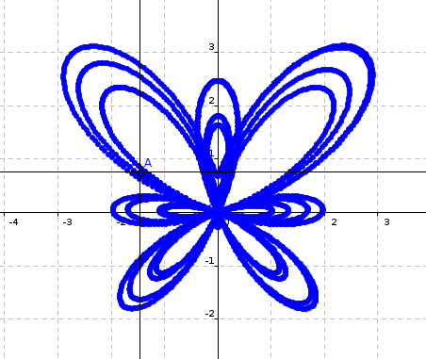 | krzywa_motylkowa.ggb | https://en.wikipedia.org/wiki/Butterfly_curve_(transcendental)
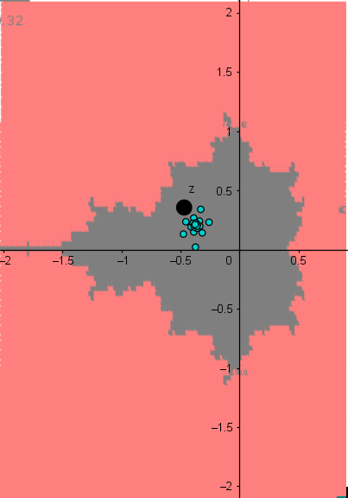 | mandelbrto_experiencer.ggb | https://pl.wikipedia.org/wiki/Zbi%C3%B3r_Mandelbrota
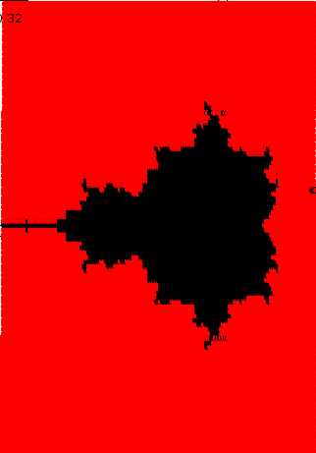 | mandelbrto_renderer.ggb | https://pl.wikipedia.org/wiki/Zbi%C3%B3r_Mandelbrota
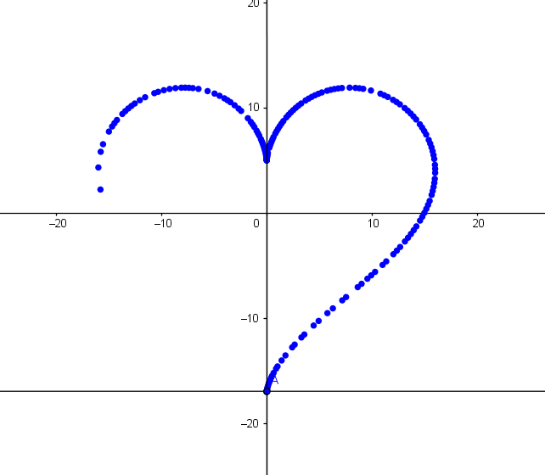 | serduszko.ggb | https://mathworld.wolfram.com/HeartCurve.html
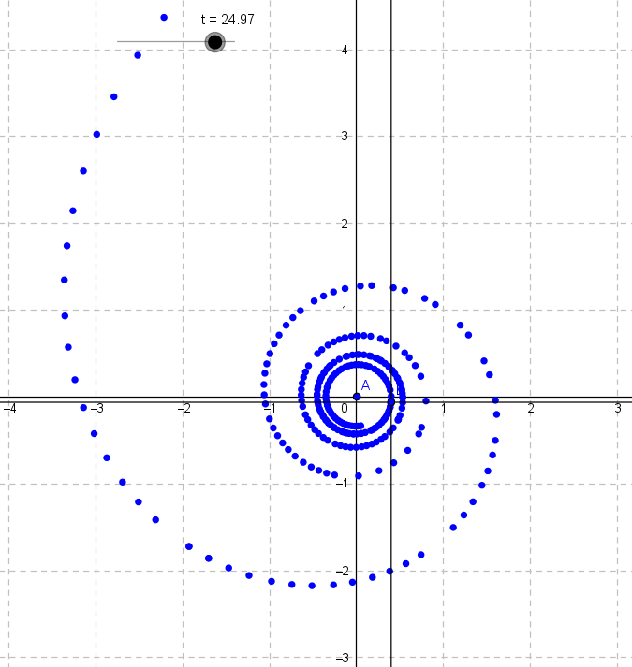 | spirala.ggb | https://pl.wikipedia.org/wiki/Spirala_hiperboliczna
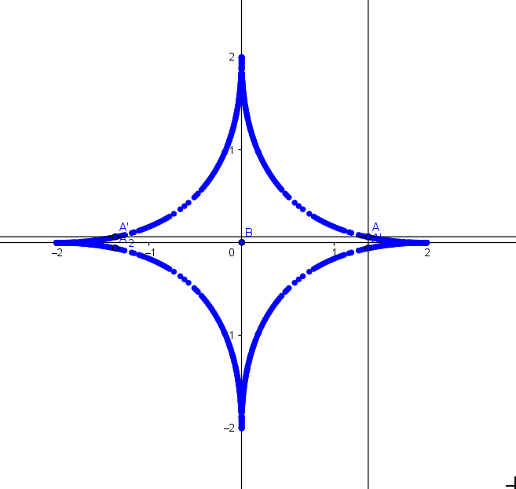 | super_elipsa.ggb | https://en.wikipedia.org/wiki/Superellipse

